- Write Bayes theorem and Explain the significance of probability in Artificial Intelligence.
- State the Baye’s theorem. How it is useful for decision making under uncertainty about knowledge?

- Explain various sources of uncertainty. How we can overcome uncertainty.

- Explain Bayesian Belief Networks with suitable example.

- What is an expert system? What factors must be considered in the determining the suitability of a problem for expert system development?
- What is an expert system? What are the main advantages in keeping the knowledge base separate from the control module in knowledge-based systems.
- List out the characteristics of expert system.

- Discuss about the expert system architecture with all its applications.

- Discuss various phases in expert system development and its applications.
- Analyze the Phases in Building Expert Systems.

- Discuss the pros and cons of Expert Systems and Traditional Systems.

- Explain about semantic web and its applications in real world scenario.
- What is semantic web? Explain how resource description framework is used to build semantic web.

- Suppose we are given the probability of mike has a cold as 0.25, the probability of mike was observed sneezing when he had cold in the past as 0.9 and the probability of mike was observed sneezing when he did not have cold as 0.20. Find the probability of mike having a cold given that he sneezes.

- Assume that TEST1 and TEST2 are conditionally independent given FLU. What is the probability of FLU (being true) given TEST1 and TEST2 (being true) if P(FLU) = 0.1 P(TEST1 | FLU) = 0.9 P(TEST1 | ¬ FLU) = 0.2 P(TEST2 | FLU) = 0.8 P(TEST2 | ¬ FLU) = 0.1

- Illustrate the advantages and disadvantages of Bayesian Belief Network.

- Explain Case Grammars with an example.

- What is the Probability that the alarm has sounded, but neither a burglary nor an earthquake has occurred, and both John and merry call.
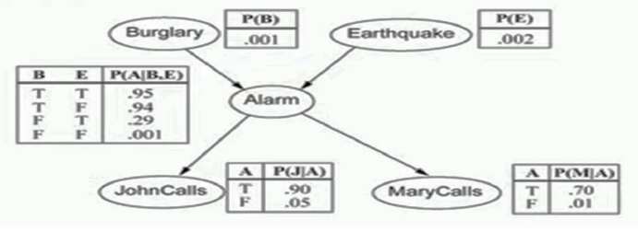

- Describe knowledge representation using Semantic Net. Give advantages and disadvantages of Semantic Net.
- Explain in detail knowledge Representation using Semantic Networks.

- Illustrate the different types of inference mechanisms used in Extended Semantic Network.
- Summarize Extended Semantic Networks.

- Explain in detail about approaches to knowledge representation.
- Describe about types of Knowledge representation?
- List and explain the various approaches of knowledge representation with example.
- Discuss about the approaches to knowledge representation in detail.
- Discus the various ways or approaches for Knowledge Representation.

- What are the properties of a good system for the knowledge representation? Discuss.

- Represent the following sentences into semantic network.
- Puss is a calico.
- Herb is tuna.
- Charlie is a tune.
- All tunas are fishes.
- All calicos are cats.
- All cats like to eat all kinds of fishes.
- Draw a semantic network representing the following knowledge:
Every vehicle is a physical object. Every car is a vehicle. Every car has four wheels. Electrical system is a part of car. Battery is a part of electrical system. Pollution system is a part of every vehicle. Vehicle is used in transportation. Swift is a car.

- Represent the following clauses in ESNet and do forward reasoning to derive John is living_thing.
- isa(X, living_thing) ---> isa(X, animate)
- isa(X, animate) ---> isa(X, human)
- isa(X, human) ---> isa(X, man)
- isa(John, man)

- Frames with examples

- Certainty Factor Theory with formulas, problems

- BBN with examples

- Classification, Regression with examples

- Supervised Learning, Unsupervised Learning

