III-B.Tech I-Semester I-Mid Term Examinations, August 2025
Key / Scheme of Evaluation
Subject: Artificial Intelligence
Subject Code: 125BA Max. Marks: 30

Q.No.  1 | Question | Marks
a. | Define Turing Test.  A test proposed by Alan Turing (1950) to measure machine intelligence: if a human interrogator cannot reliably distinguish between answers given by a human and a machine through conversation, the machine is said to exhibit intelligent behavior. | 1
b. | List any two applications of AI in real world.  - Natural Language Processing (e.g., Chatbots, Translation).  - Computer Vision (e.g., Facial Recognition, Autonomous Vehicles).  - Others: Expert systems, Medical diagnosis, Recommendation engines. | 1
c. | What is the main difference between uninformed search and heuristic search?  - Uninformed search: No domain-specific knowledge; only uses problem definition (e.g., BFS, DFS).  - Heuristic search: Uses problem-specific heuristic functions to guide search efficiently (e.g., Greedy, A*). | 1
d. | Give examples of two-player games.  Chess, Tic-tac-toe, Checkers, Go. | 1
e. | Write the formula for Disjunctive Normal Form (DNF).  A logical formula expressed as a disjunction (OR) of conjunctions (AND) of literals.  Example: (A∧B)∨(¬C∧D) | 1
f. | Express the statement: “If it rains, the ground is wet” in propositional logic.  Let R: It rains, W: Ground is wet. Statement: R→W. | 1
g. | How do you convert PNF into Standard Form?  Steps:  - Read the quantifiers from left to right.  - If you see an existential quantifier (∃x) first, replace that variable with a new constant (not used before) and remove the quantifier.  - If you see an existential quantifier (∃x) after some universal quantifiers (∀y), replace that variable with a new function of those universal variables (called a Skolem function), and remove the quantifier.  - Repeat this process until all existential quantifiers are removed.  - Convert the remaining formula (matrix) into CNF (Conjunctive Normal Form). | 1
h. | State the Resolution rule in propositional logic.  If one clause contains a literal A and another contains its negation ¬A, then we can resolve them by removing A and ¬A and forming a new clause with the remaining literals.  Example: (A∨B),(¬A∨C)⇒(B∨C) | 1
i. | What is meant by knowledge representation?  Knowledge Representation (KR) is the way information is stored and organized so that it can be used for reasoning and problem-solving. | 1
j. | List any two knowledge representation techniques.  - Semantic Networks.  - Predicate Logic.  - Frames, Production Rules. | 1
Q.2(a) | Differentiate Breadth-First Search and Depth-First Search with respect to completeness, optimality, space and time complexity.  - Completeness: BFS is complete (will always find a solution if it exists); DFS is not (may go into infinite branch).  - Optimality: BFS is optimal if all step costs are equal; DFS is not optimal.  - Time Complexity: BFS = O(b^{d}); DFS = O(b^{m}).  - Space Complexity: BFS = O(b^{d}); DFS = O(bm). | 3
(b) | Explain the concept of Evaluation Function in Game Playing.  A function that estimates the “goodness” of a game state for a player, guiding search without exploring entire game tree.  Example: In Tic-tac-toe, the evaluation function can count the number of open winning lines (rows, columns, diagonals) available to each player.  Eval(state)=(number of lines still open for MAX)−(number of lines still open for MIN). | 2
Q.3 | Consider the following search tree with start node S and goal node G.  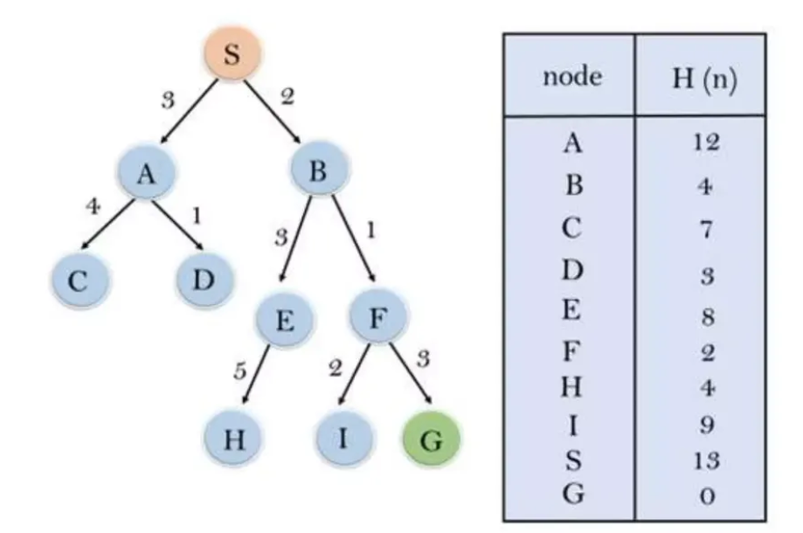  - Apply Greedy Best-First Search to find the path from S to G. Show the sequence of node expansions and the path obtained.  - Apply the A* search algorithm on the same graph. Clearly show the values of g(n), h(n), and f(n)=g(n)+h(n) at each step, and determine the optimal path cost.  a) 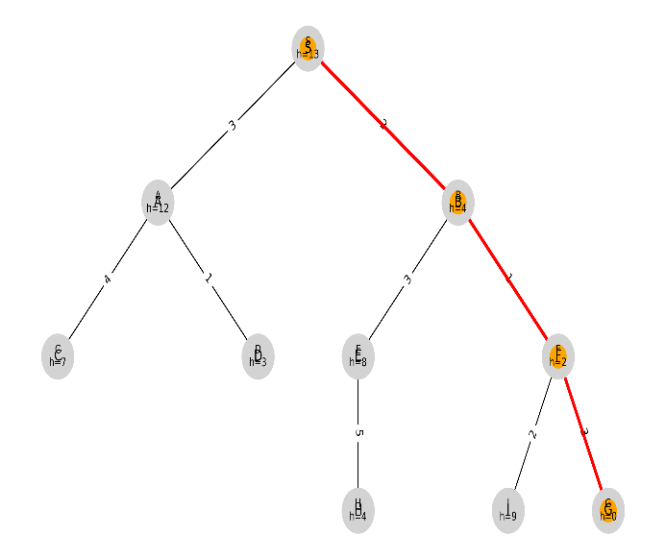 b) 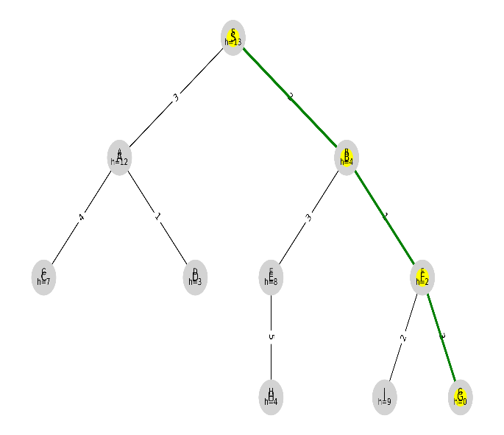  Path found: S → B → F → G Optimal path (backpointers): S → B → F → G  Path cost (sum of arc costs): 2 + 1 + 3 = 6. Optimal path cost: g(G) = 6. | 5
Q.4(a) | State and explain Semantic Tableau Method in propositional logic.  A systematic procedure to test satisfiability of formulas by breaking them into components.  For example to show ( Q Λ ~ R) Λ ( R → P) is consistent: Consider  {Tableau root} ( Q Λ~ R)Λ( R → P) (1)  {Apply rule 1 to 1} (Q Λ ~ R) (2)  ( R→P) (3)  {Apply rule 1 to 2} Q  ~R  {Apply rule 6 to 3} ~ R P  open open  So ( Q Λ ~ R) Λ ( R → P) is consistent | 3
(b) | Translate the following into predicate logic: “All humans are mortal. Socrates is a human.”  - All humans are mortal: ∀x(Human(x)→Mortal(x)).  - Socrates is a human: Human(Socrates).  - This logically infer: Mortal(Socrates). | 2
Q.5 | Consider the following knowledge base:  - Every student studies.  - Everyone who studies passes.  - Ravi is a student.  (a) Represent the above premises in predicate logic.  (b) Use the Resolution Refutation method to prove that Ravi passes.  (a)  - Every student studies → ∀x(Student(x)→Studies(x)).  - Everyone who studies passes → ∀x(Studies(x)→Passes(x))  - Ravi is a student → Student(Ravi).  (b)  - ~ Passes(Ravi) [To prove that Ravi passes, its negation is considered]  From (ii) and (iv), x=Ravi: ~Studies(Ravi)  From (i), x= Ravi: ~Student(Ravi).  From (iii): Nil (no terms left)  So Ravi passes is true | 5
Q.6(a) | Compare Semantic Networks and Predicate Logic in representing knowledge.  - Semantic Networks: Graphical, intuitive, good for inheritance; but ambiguous and less formal.  - Predicate Logic: Symbolic, precise, allows quantifiers and inference; but less intuitive for humans. | 2
(b) | Draw a Semantic Network for: A dog is an animal. A cat is an animal. Tom is a cat. Jerry is a dog. Tom and Jerry eat food.  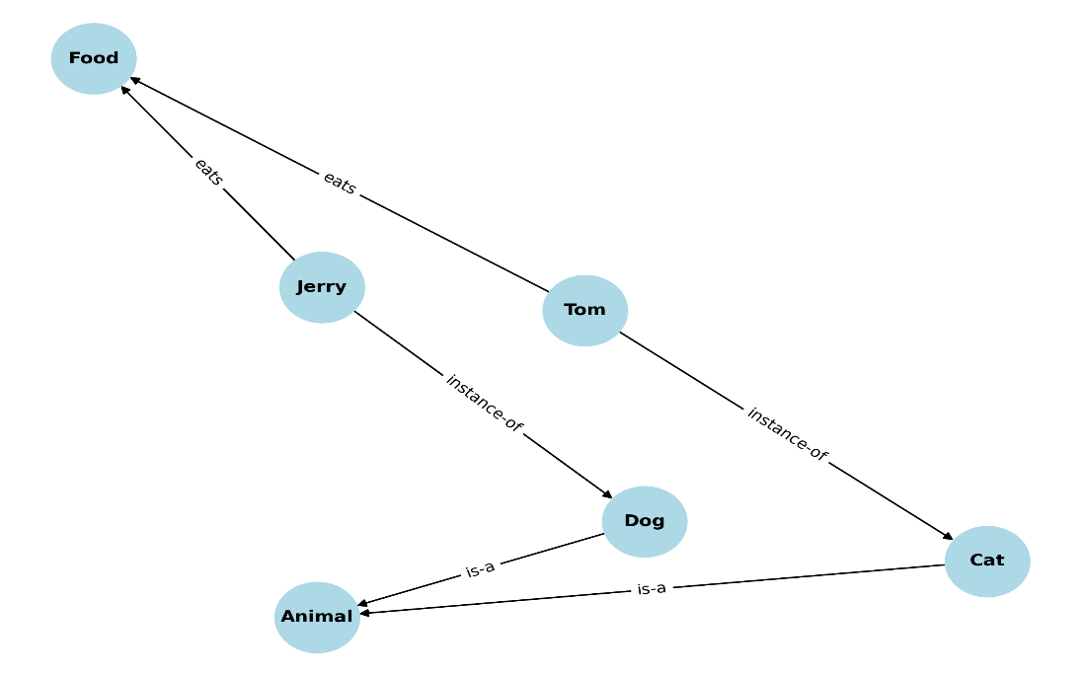 | 3
Q.7(a) | What is an alpha beta cut off? Explain with an example.  A pruning technique in minimax search that eliminates branches which cannot affect the final decision.  Example: If a MAX node already has a value higher than the MIN bound, further sibling exploration is skipped.  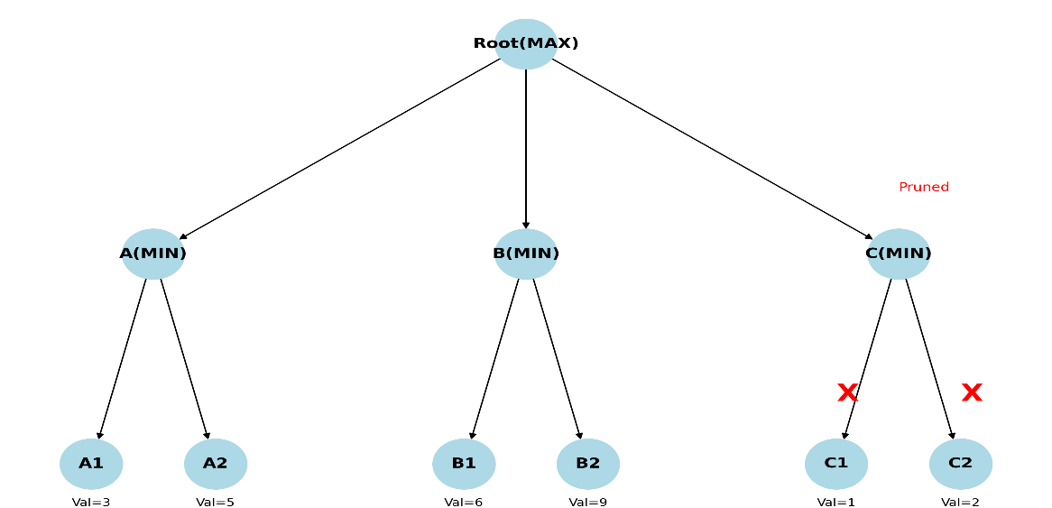 | 2
(b) | Use the Semantic Tableau Method to test satisfiability of the following formula: (P ∨ Q) ∧ (¬P ∨ R) ∧ (¬R)  (Root} (P ∨ Q) ∧ (¬P ∨ R) ∧ (¬R) (1)  {Apply rule 1 to 1} (P ∨ Q) (2)  (¬P ∨ R) (3) Q  (¬R) (4)  {Apply rule 3 to 2} P Q (5)  {Apply rule 3 to 2} ¬P R (6)  closed  {4} (¬R)  closed  Q is open, so the formula: (P ∨ Q) ∧ (¬P ∨ R) ∧ (¬R) is satisfiable. | 3

