ML Assignment-1

S.No. | Question | Marks | Bloom’s Level | CO
A1 | Consider a hypothesis space defined over the instances given in the following table. Give a trace of CANDIDATE-ELIMINATION algorithm learning from these instances and show G and S boundaries.  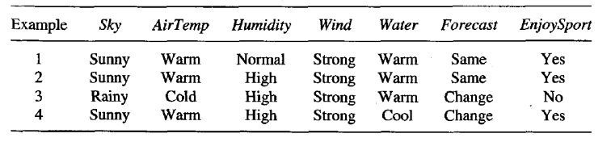 | 1 | 2 | 1
A2 | Discuss Overfitting in Decision Trees and methods to avoid it. | 1 | 2 | 2
A3 | Consider the following neural network and update the W1 and W5 weights using back propagation algorithm? Show the new values of updated W1 and W5 weights.  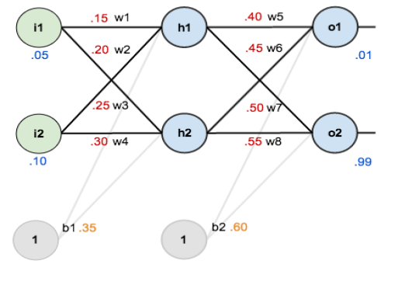 | 2 | 3 | 2
A4 | Consider a dataset with two linearly separable classes. Show how an SVM identifies the optimal separating hyperplane. | 1 | 4 | 3

