AI Assignment – I

S.No. | Question | Marks | Bloom’s Level | CO
A1 | Solve the following game tree using α–β pruning. Show pruned branches clearly.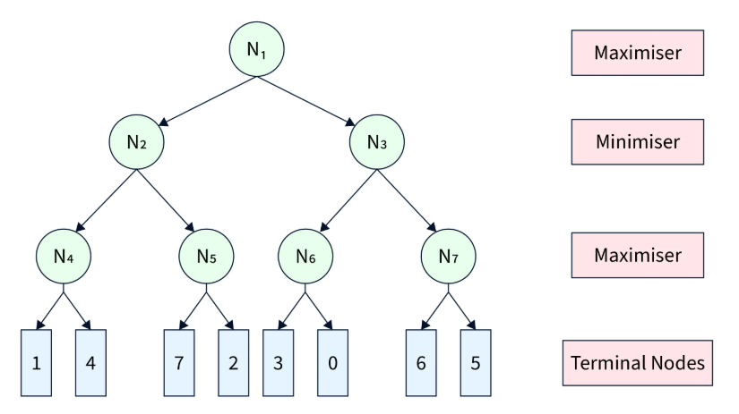 | 1 | 3 | 2
A2 | Solve the following Cryptarithmetic problem using constraint satisfaction:  S E N D  + M O R E  ---------------  M O N E Y | 1 | 4 | 2
A3 | Convert the following English statements into Propositional Logic and Predicate Logic forms:  “All humans are mortal.”  “Socrates is a human.”  “If Socrates is a human, then Socrates is mortal.” | 1 | 2 | 3
A4 | Draw a Semantic Network to represent the following knowledge:  A cat and a dog are animals.  Tom is a cat. Jerry is a dog.  Both Tom and Jerry eat food.  Cats drink milk. | 2 | 2 | 4

