M.Tech II-Semester I-Mid Term Examinations, June 2023
Subject: Principles of Artificial Intelligence and Machine Learning
Subject Code: 522EQ Max. Marks: 30
Time: 2 Hrs. Date: 09-06-2023
Blooms Taxonomy Levels:
Level 1 – Remembering, Level 2 – Understanding, Level 3 – Applying,
Level 4 – Analyzing, Level 5 – Evaluating, Level 6 - Creating

PART – A (1 X 10 = 10 M)
Answer all Questions. Each Question carries 1 Mark.
Q.No.1 | Question | Marks | Bloom’s Level | CO
a. | What do you mean by Agent? | 1 | 1 | 1
b. | What do you mean by Utility function? | 1 | 1 | 1
c. | What is State Space search? | 1 | 1 | 1
d. | What is the need for Heuristic function? | 1 | 1 | 2
e. | What is Alpha cutoff and Beta cutoff? | 1 | 1 | 3
f. | What is Constraint Satisfaction Problem? | 1 | 1 | 3
g. | Define Bayes rule. | 1 | 1 | 3
h. | What is h_{MAP}? | 1 | 1 | 3
i. | List out any four applications of Machine Learning. | 1 | 1 | 5
j. | What do you mean by Reinforcement Learning? | 1 | 1 | 5
PART – B (4 X 5 = 20M)
Answer any FOUR full Questions. Each question carries 5 Marks.
Q.No. | Question | Marks | Bloom’s Level | CO
Q2. a) | Define Artificial Intelligence (AI). Give details of the foundation of AI. | 3 | 2 | 1
b) | Explain the concept of Simple Reflex Agent with an example. | 2 | 2 | 1
Q.3. a) | Explain Breath First Search in detail with a suitable example. | 3 | 3 | 2
b) | Sketch the differences between Informed Search and Uninformed Search. | 2 | 4 | 1
Q.4. a) | Given the following search tree, apply the Alpha-Beta Pruning algorithm to it and find out the alpha beta cuts for the following tree.  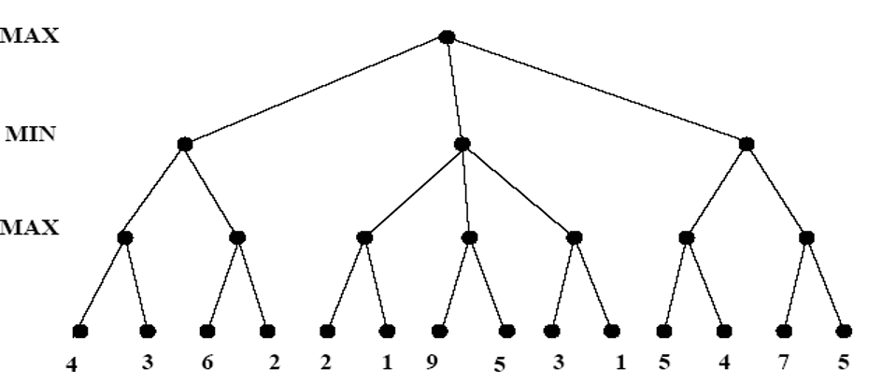 | 3 | 4 | 3
b) | Discuss about Map-coloring problems, with example | 2 | 2 | 3
Q.5. a) | The following data set contains factors that determine whether tennis is played or not. Using Naive Bayes Classifier, find the play prediction for the day <Sunny, Cool, High, Strong>  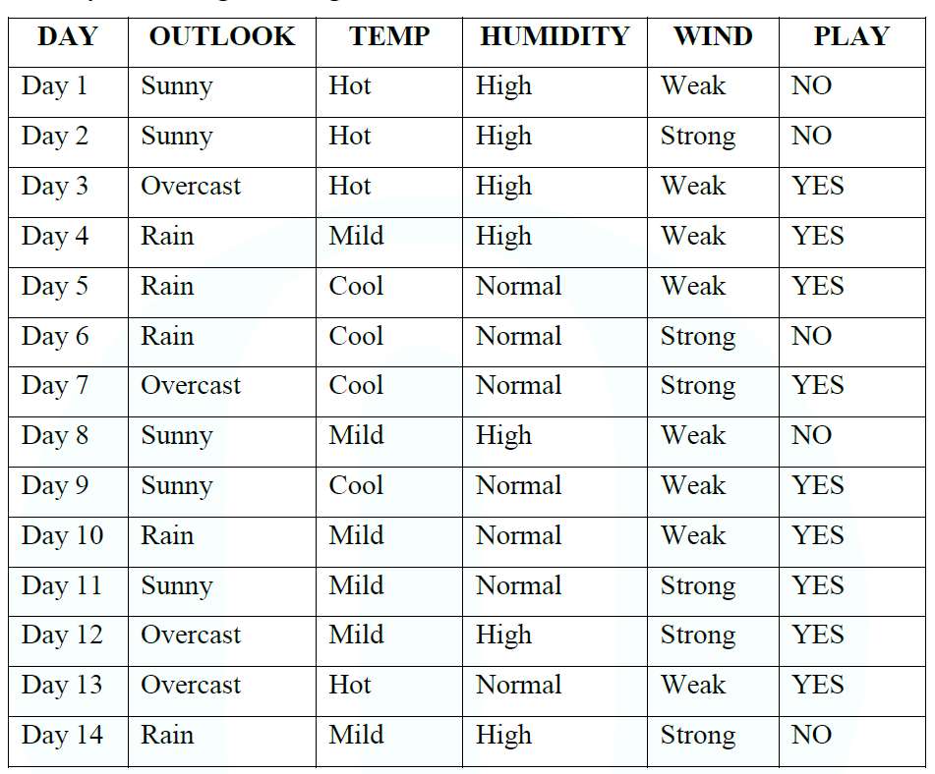 | 3 | 4 | 3
b) | A patient takes a lab test and the result comes back positive. It is known that the test returns a correct positive result in only 98% of the cases and a correct negative result in only 97% of the cases. Furthermore, only 0.008 of the entire population has this disease.  i. What is the probability that this patient has cancer?  ii. What is the probability that he does not have cancer? | 2 | 5 | 3
Q.6. a) | What is Machine Learning? Differentiate between Supervised Learning and Unsupervised Learning. | 3 | 4 | 5
b) | Explain Regression with an example. | 2 | 2 | 5
Q.7. a) | Explain A* algorithm in detail with a suitable example. | 3 | 3 | 2
b) | What is Minimax search for game playing? Explain the Minimax algorithm. | 2 | 3 | 3

