G. NARAYANAMMA INSTITUTE OF TECHNOLOGY & SCIENCE (For Women)
(AUTONOMOUS)
DEPARTMENT OF ELECTRONICS AND TELEMATICS ENGINEERING
OPEN BOOK TEST
Class: III B.Tech I Sem Date: 09-11-2024
Subject: Artificial Intelligence (125BA) Marks: 5 X 3 = 15
- What is semantic web? Explain how resource description framework is used to build semantic web.
- Write Bayes theorem and explain the significance of probability in Artificial Intelligence.
- Suppose we are given the probability of mike has a cold as 0.25, the probability of mike was observed sneezing when he had cold in the past as 0.9 and the probability of mike was observed sneezing when he did not have cold as 0.20. Find the probability of mike having a cold given that he sneezes.
- What is the Probability that the alarm has sounded, but neither a burglary nor an earthquake has occurred, and both John and merry call.?
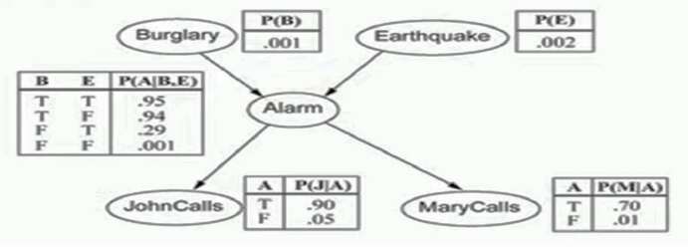
- Discuss about the expert system architecture with all its applications.

