IMPORTANT QUESTIONS FOR OPEN BOOK TEST
- What is semantic web? Explain how resource description framework is used to build semantic web.
- Explain Case Grammars with an example.
-------------------------------------------------------------------------------------------------------
- Write Bayes theorem and explain the significance of probability in Artificial Intelligence.
- Explain Bayesian Belief Networks with suitable example.
- Illustrate the advantages and disadvantages of Bayesian Belief Network.
- Suppose we are given the probability of mike has a cold as 0.25, the probability of mike was observed sneezing when he had cold in the past as 0.9 and the probability of mike was observed sneezing when he did not have cold as 0.20. Find the probability of mike having a cold given that he sneezes.
- Assume that TEST1 and TEST2 are conditionally independent given FLU. What is the probability of FLU (being true) given TEST1 and TEST2 (being true) if P(FLU) = 0.1 P(TEST1 | FLU) = 0.9 P(TEST1 | ¬ FLU) = 0.2 P(TEST2 | FLU) = 0.8 P(TEST2 | ¬ FLU) = 0.1
- What is the Probability that the alarm has sounded, but neither a burglary nor an earthquake has occurred, and both John and merry call.?
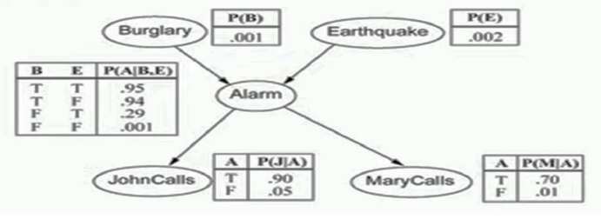
-------------------------------------------------------------------------------------------------------
- Discuss about the expert system architecture with all its applications.
- Discuss various phases in expert system development and its applications.
NOTE: Out of these 10 questions, 5 questions will be asked in open book test, out of which 2 are problems and 3 theory each from 1 unit

