AI Important Questions
- Define Artificial Intelligence. List the applications of AI. Explain the applications of Artificial intelligence.
- Explain in detail about definitions of AI in the following approaches.
i) Acting Humanly
ii) Thinking Humanly
iii) Thinking Rationally
iv) Acting Rationally
- Explain about the foundations of AI. List out sub areas of Artificial Intelligence.
----------------------------------------------------------------------------------------------------------------
- Write a short note on model based reflex agents and utility-based agent with relevant diagrams.
- With neat diagram brief on Goal based agent.
- Illustrate self-driving car with PEAS representation.
- List and explain the properties of environments.
----------------------------------------------------------------------------------------------------------------
- Discuss the characteristics of AI problem. Explain Towers of Hanoi problem considering it as an AI problem.
- Write short notes on forward reasoning and backward reasoning.
- Is a problem-solving search program was to be written to solve the water jug problem, determine whether the search should proceed forward or backward.
- List the steps involved in simple problem solving technique.
----------------------------------------------------------------------------------------------------------------
- Differentiate between informed and uninformed search strategies.
- Illustrate the following uninformed search strategies with example.
i) Breadth First Search. ii) Uniform Cost Search iii) Depth First Search
- Explain the process to reach goal state in DFS.
- Write the algorithm for breadth first and depth first search.
- Solve the problem given below where S is the initial state and G is the goal state with each edge having equal weightage using BFS and find time complexity.
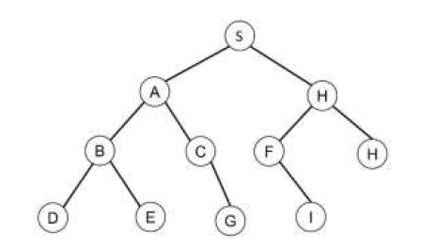
----------------------------------------------------------------------------------------------------------------
- Define heuristic search? What are the advantages of heuristic search?
- What are the various heuristic techniques? Explain how they are different from the solution guaranteed uninformed techniques.
- Explain A* searching technique in detail with example. Explain various stages of A* search with an example. Discuss conditions for the optimality of this technique.
----------------------------------------------------------------------------------------------------------------
- Give examples of game trees.
- What are optimal decisions in games.
- How the following techniques help in understanding in two player game? Explain
i) Mini-Max Algorithm ii) Alpha-Beta Pruning
- What is the Mini Max search for game playing? Explain Mini Max search algorithm with an example.
- Solve the below tree with min-max procedure.
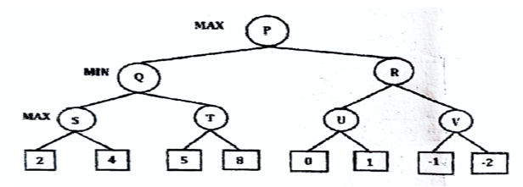
- What is an alpha beta cut off? Explain it using suitable example.
- Solve the following using alpha-beta pruning.
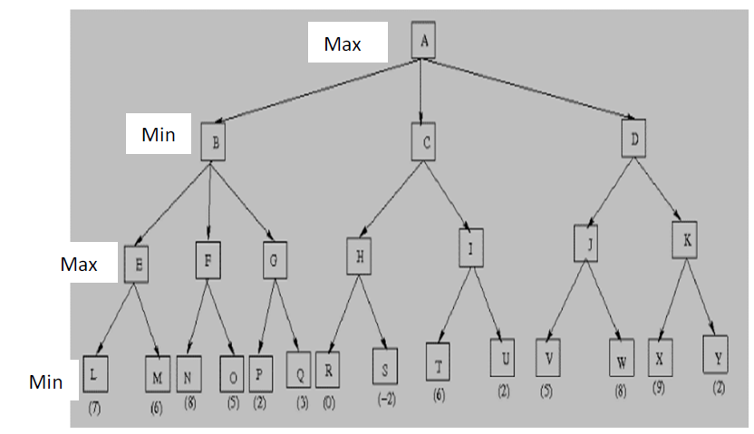
- Define Constraint Satisfaction Problem (CSP). How CSP is formulated as a search problem? Explain with an example.
- Explain Constraint Satisfaction Problems. Discuss Cryptarithmetic problem with an example.
----------------------------------------------------------------------------------------------------------------
- Explain hill-climbing algorithm with an example. List two problems associated with hill-climbing algorithm.
- List out features of Hill Climbing. Analyze the steps in simple Hill Climbing.
- Find the value of the function “maximum” in hill climbing, assuming the function to be negative of the number of tiles “out of place” in the 8 puzzle problem, give the initial and goal states as shown
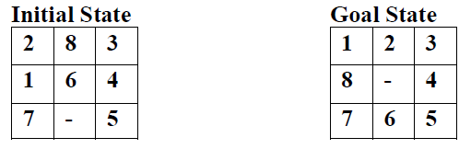
----------------------------------------------------------------------------------------------------------------
- Prove the following statement in propositional logic
A B is logically equivalent with ~ A V B
- Determine whether the following is Satisfiable, Contradictory or Valid:
(P V Q) ^ ~ (P V Q).
- What is an inference engine? Describe backward and forward chaining mechanism used by an inference engine.
----------------------------------------------------------------------------------------------------------------
- Let us consider the following
p = It is raining
q = Mary is sick
t = Bob stayed up late last night
r = Paris is the capital of France
s = John is a loud-mouth
Express the following statements in propositional logic
i. It is raining and Mary is sick
ii. Bob stayed up late last night and John is a loud-mouth
iii. Paris isn’t the capital of France and It isn’t raining
iv. John is a loud-mouth but Mary isn’t sick
v. It is not the case that it is raining and Mary is sick
- What is Natural Deduction System? Explain in detail.
- Prove the following theorem using deductive inference rules.
From A → B ˄ C, A infer C, from A ˄ B, A → C infer C.
- State and explain semantic tableau system in propositional logic.
- Discuss in detail Resolution Refutation in Propositional Logic with suitable examples.
----------------------------------------------------------------------------------------------------------------
- Define predicate logic. Give example.
- Express the following statement in predicate logic “Vijaya is a student of GNITS”
- Define syntactic relation of first order logic. Explain use of first order logic to represent knowledge with example.
- Differentiate between propositional logic and First Order Logic. List the inference rules along with suitable examples for First Order Logic
- Differentiate Propositional logic and Predicate logic.
- Analyze Unification Algorithm with suitable example.
- Give the basic principle of resolution. Explain resolution in predicate logic with an example.
- Consider the following set of well formed formulas in predicate logic:
(i)Man(Marcus)
(ii) Pompeian(Marcus)
(iii) ∀x: Pomeian(x) →Roman(x)
(iv)Ruler(Caeser)
(v) ∀x: Roman(x) → Loyalto (x, Caeser) V hate( x, caeser)
(vi) ∀x: y loyalto (x,y)
(vii) ∀x: ∀y: Man(x) ∧ Ruler (y) ∧ tryassassinate (x,y) → loyalto (x,y)
(viii) tryassassinate (Marcus, Caeser)
Convert these into clause form and prove that hate(Marcus, caeser) using resolution proof.
- Translate the following sentences into formulas in predicate logic and Prove that “john like peanuts” using backward chaining.
i) John likes all kind of food.
ii) Apples are food.
iii) Chicken is food.
iv) Anything anyone eats and is not killed by is food.
v) Bill eats peanuts and is still alive.
vi) Sue eats everything Bill eats.
----------------------------------------------------------------------------------------------------------------
- List and explain the various approaches of knowledge representation with example.
- What are the properties of a good system for the knowledge representation? Discuss.
----------------------------------------------------------------------------------------------------------------
- Describe knowledge representation using Semantic Net. Give advantages and disadvantages of Semantic Net.
- Represent the following sentences into semantic network.
Puss is a calico.
Herb is tuna.
Charlie is a tune.
All tunas are fishes.
All calicos are cats.
All cats like to eat all kinds of fishes.
- Draw a semantic network representing the following knowledge:
Every vehicle is a physical object. Every car is a vehicle. Every car has four wheels. Electrical system is a part of car. Battery is a part of electrical system. Pollution system is a part of every vehicle. Vehicle is used in transportation. Swift is a car.

