Assignment-1
Subject: Artificial Intelligence Branch: ETM
Subject Code: 125BA Max Marks: 5
S.No. | Question | Marks | Bloom’s Level | CO
A1 | Solve the following using alpha-beta pruning.  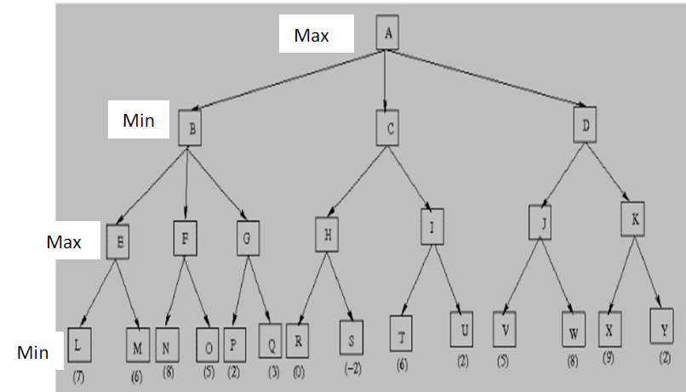 | 2 | 4 | 2
A2 | Explain hill-climbing algorithm with an example. | 1 | 2 | 2
A3 | Let us consider the following  p = It is raining  q = Mary is sick  t = Bob stayed up late last night  r = Paris is the capital of France  s = John is a loud-mouth  Express the following statements in propositional logic  i. It is raining and Mary is sick  ii. Bob stayed up late last night and John is a loud-mouth  iii. Paris isn’t the capital of France and It isn’t raining  iv. John is a loud-mouth but Mary isn’t sick  v. It is not the case that it is raining and Mary is sick | 2 | 3 | 3

