- Define Artificial Intelligence. Explain about the foundations of AI. List the applications of AI.
- Illustrate the following uninformed search strategies with example.
i) Breadth First Search. ii) Uniform Cost Search iii) Depth First Search
- Define heuristic search? What are the advantages of heuristic search?
- Solve the below tree with min-max procedure.
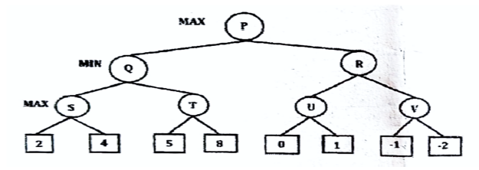
- Explain A* searching technique in detail with example. Discuss conditions for the optimality of this technique.
- Explain Alpha-Beta pruning with an example.
- Explain Constraint Satisfaction Problems. Discuss Cryptarithmetic problem with an example.

