UNIT – 1
a) Define percept sequence of an agent.
d) List various task domains of Artificial Intelligence.
e) What is the significance of utility functions in decision making?
j) What are the phases involved in designing a problem solving agent?
----------------------------------------------------------------------------------------------------------------
8) What is an agent?
----------------------------------------------------------------------------------------------------------------
Explain the process of decision making using utility functions.
----------------------------------------------------------------------------------------------------------------
3. What is the relevance of search and control strategies in problem solving?
4. What are the Problem Characteristics of Artificial Intelligence?
5. What is Heuristics?
10. What is state space?
----------------------------------------------------------------------------------------------------------------
Explain the following in brief:
1. Need of formulating the problems in AI.
3. Advantages of logical reasoning.
7. Major reasons for growth of intelligent agents.
8. Features of utility functions in decision making.
10. Future scope of artificial intelligence.
----------------------------------------------------------------------------------------------------------------
a) State the relationship between Intelligence and Knowledge.
c) What are the various applications of AI?
h) Mention the criteria for the evaluation of search strategy.
j) What is Heuristics?
----------------------------------------------------------------------------------------------------------------
a. Need of heuristic functions.
----------------------------------------------------------------------------------------------------------------
a) What is state space search?
----------------------------------------------------------------------------------------------------------------
10) What is a search path
----------------------------------------------------------------------------------------------------------------
a. What do you mean by Agent?
d. What is Heuristic search?
g. What is a Search graph?
h. Define Random search.
----------------------------------------------------------------------------------------------------------------
Define Artificial Intelligence (AI). Differentiate between strong AI and Weak AI.
----------------------------------------------------------------------------------------------------------------
a) What is an AI technique? Explain briefly.
b) Write about some of the cross domains of Artificial intelligence.
----------------------------------------------------------------------------------------------------------------
What do you mean by AI? Explain contribution of AI in various fields.
----------------------------------------------------------------------------------------------------------------
What are the characteristics of AI & what are the various issues with AI?
----------------------------------------------------------------------------------------------------------------
Give details of the foundation of artificial intelligence. How AI is being used in the area of human machine interaction research?
----------------------------------------------------------------------------------------------------------------
a) Explain the current trends in AI.
b) Briefly Explain the history of Artificial Intelligence.
----------------------------------------------------------------------------------------------------------------
Define Artificial Intelligence and list the task domains of Artificial Intelligence.

The domain of AI is classified into different task categories such as Mundane/General tasks, Formal tasks and Expert tasks.

Mundane tasks are the ones that we (humans) do on regular basis without any special training such as computer vision, speech recognition, Natural language processing, generation and translation etc. Common sense, reasoning and planning are the common characteristics of these tasks.

Formal tasks - are the ones where there is an application of formal logic, some learning etc. Verifications, Theorem proving etc are the common characteristics. Games such as Chess Checkers, Go etc are classified in these task.

Expert tasks - Tasks which requires high analytical and thinking skills, a job only a professionals can do. Expert task which comes under functional expert domain such as engineering, fault finding, manufacturing planning, medical diagnosis etc.

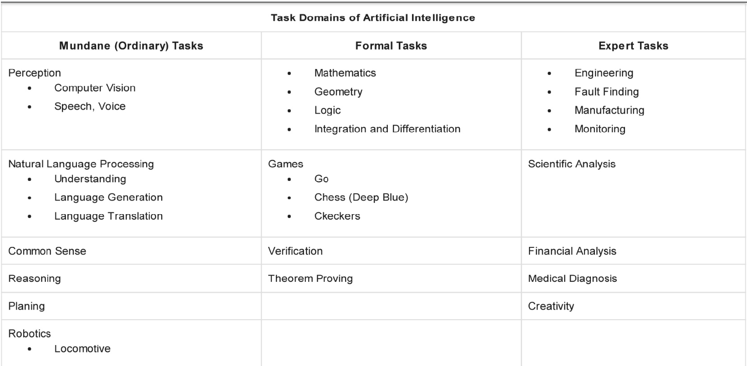
----------------------------------------------------------------------------------------------------------------
How Artificial Intelligence is related to human based nature? Develop PEAS description for the following task environment: Shopping for used AI books on the Internet
----------------------------------------------------------------------------------------------------------------
“AI is interdisciplinary in nature and its foundations are in various fields.” Justify the statement with valid reasons.
----------------------------------------------------------------------------------------------------------------
a) Explain in detail the applications of Artificial Intelligence.
b) Discuss categorization of intelligent systems.
----------------------------------------------------------------------------------------------------------------
Write a short note on the following, with example:
a) Backtracking Search
b) Learning using intelligent agents
----------------------------------------------------------------------------------------------------------------
Elaborate “The Turing Test”. What would a computer need to pass the Turing test?
----------------------------------------------------------------------------------------------------------------
Explain the concept of simple reflex agent with an example.
----------------------------------------------------------------------------------------------------------------
Write a short note on goal based intelligent agents, with diagram
----------------------------------------------------------------------------------------------------------------
Write a short note on the following, with example:
a) Backtracking Search
b) Learning using intelligent agents
c) Importance of Search techniques in AI
----------------------------------------------------------------------------------------------------------------
Write a short note on model-based intelligent agent, with diagram
----------------------------------------------------------------------------------------------------------------
Distinguish between forward and backward chaining.
----------------------------------------------------------------------------------------------------------------
A Water Jug Problem: You are given two jugs, a 4-gallon one and a 3-gallon one, a pump
which has unlimited water which you can use to fill the jug, and the ground on which water
may be poured. Neither jug has any measuring markings on it. How can you get exactly 2
gallons of water in the 4-gallon jug
(i) Write down the production rules for the above problem
(ii) Write any one solution to the above problem
----------------------------------------------------------------------------------------------------------------
Give details of the year-wise development of AI.
----------------------------------------------------------------------------------------------------------------
Describe any four informed searching techniques with suitable examples.
----------------------------------------------------------------------------------------------------------------
Differentiate between forward chaining and backward chaining.
OR
Distinguish between forward and backward chaining.

----------------------------------------------------------------------------------------------------------------
What are the characteristics of a AI problem. Discuss with the help of travelling salesman problem.
----------------------------------------------------------------------------------------------------------------
Explain state space approach for solving any AI problem.
----------------------------------------------------------------------------------------------------------------
Sketch the difference between:
a. Informed Search Vs Uninformed Search.
Parameters | Informed Search | Uninformed Search
Utilizing Knowledge | It uses knowledge during the process of searching. | It does not require using any knowledge during the process of searching.
Speed | Finding the solution is quicker. | Finding the solution is much slower comparatively.
Completion | It can be both complete and incomplete. | It is always bound to be complete.
Consumption of Time | Due to a quicker search, it consumes much less time. | Due to slow searches, it consumes comparatively more time.
Cost Incurred | The expenses are much lower. | The expenses are comparatively higher.
Suggestion/ Direction | The AI gets suggestions regarding how and where to find a solution to any problem. | The AI does not get any suggestions regarding what solution to find and where to find it. Whatever knowledge it gets is out of the information provided.
Efficiency | It costs less and generates quicker results. Thus, it is comparatively more efficient. | It costs more and generates slower results. Thus, it is comparatively less efficient.
Length of Implementation | Implementation is shorter using AI. | The implementation is lengthier using AI.
Examples | A few examples include Graph Search and Greedy Search. | A few examples include Breadth-First Search or BFS and Depth-First Search or DFS.

b. Forward Chaining Vs Backward Chaining.
----------------------------------------------------------------------------------------------------------------
State and explain algorithm for Best First Search Algorithm with an example.
----------------------------------------------------------------------------------------------------------------
Explain Breath First Search in detail with a suitable example.
----------------------------------------------------------------------------------------------------------------
Differentiate between the depth first search and breadth first search with the help of suitable example.
----------------------------------------------------------------------------------------------------------------
Show that DFS is neither complete nor optimal search.
----------------------------------------------------------------------------------------------------------------
Discuss the main aspects considered before solving a complex AI problem. State your understanding on state space representation in AI.
----------------------------------------------------------------------------------------------------------------
What do you mean by Utility functions? Explain in detail.
----------------------------------------------------------------------------------------------------------------
Explain state space approach in solving any Al problem. Discuss this for water jug problem.
----------------------------------------------------------------------------------------------------------------
What are the various heuristic techniques. Explain how they are different from the solution guaranteed techniques.
----------------------------------------------------------------------------------------------------------------
What are the possible heuristics for the Travelling Salesman Problem?
----------------------------------------------------------------------------------------------------------------
Distinguish between forward and backward chaining.
----------------------------------------------------------------------------------------------------------------
a) Discuss A* algorithm in detail.
----------------------------------------------------------------------------------------------------------------
Explain A* algorithm in detail with a suitable example.
----------------------------------------------------------------------------------------------------------------
Explain A* searching technique in detail with example. Discuss conditions for the optimality of this technique.
----------------------------------------------------------------------------------------------------------------
a) Explain about hill climbing heuristic search technique.
b) Discuss in detail about alpha-beta pruning.
----------------------------------------------------------------------------------------------------------------
Write an algorithm for A* searching technique. Explain with the help of suitable example.
----------------------------------------------------------------------------------------------------------------
Discuss the following, with example:
- Intelligent Agents
- A* Algorithm
==================================================================
UNIT – 2
8) What is probabilistic reasoning?
----------------------------------------------------------------------------------------------------------------
7. Explain the Bayesian Networks.
----------------------------------------------------------------------------------------------------------------
Explain the following in brief :
2. Alpha-beta pruning.
5. Characteristics of bayes rule.
----------------------------------------------------------------------------------------------------------------
f) What is rule based learning?
----------------------------------------------------------------------------------------------------------------
d. Implementation challenges in representation of resource constraints.
----------------------------------------------------------------------------------------------------------------
b) What is Conflict Resolution Strategies
f) What is a belief network
----------------------------------------------------------------------------------------------------------------
f) Define Bayes rule.
h) State the principle of Belief networks.
----------------------------------------------------------------------------------------------------------------
c. Define the Bayesian Networks.
i. Define Conditional Probability.
----------------------------------------------------------------------------------------------------------------
Explain Bayesian networks with example.
----------------------------------------------------------------------------------------------------------------
Write down the algorithm of N-Queens’s problem. Discuss its important in real life.
----------------------------------------------------------------------------------------------------------------
While understanding the basic perceptron model of Neural Network; you are asked to design and represent the Boolean functions of NAND and NOR gates using the similar logic. Further put forward a discussion about the XOR function
----------------------------------------------------------------------------------------------------------------

Illustrate your idea on constraint satisfaction problems, with appropriate example?
----------------------------------------------------------------------------------------------------------------
Write the alpha-beta search algorithm. What is the role of the transposition table in this algorithm?
----------------------------------------------------------------------------------------------------------------
What is the mini Max search technique? What is a alpha beta cutoff?
----------------------------------------------------------------------------------------------------------------
What is minimax search for game playing? Explain the Min Max algorithm
----------------------------------------------------------------------------------------------------------------
a) Search in game playing programs always proceeds forward from current state to goal state. Why? Explain.
b) Explain the problem characteristics.
----------------------------------------------------------------------------------------------------------------
Explain about Tic-Tac-Toe game problem by assuming one player is X the other one can be either human or a computer by taking 3Χ3 grid space.
----------------------------------------------------------------------------------------------------------------
Discuss about Map-coloring problems, with example
----------------------------------------------------------------------------------------------------------------
Explain the usage of alpha beta pruning in Game Playing. Find out the alpha beta cuts for the following tree.
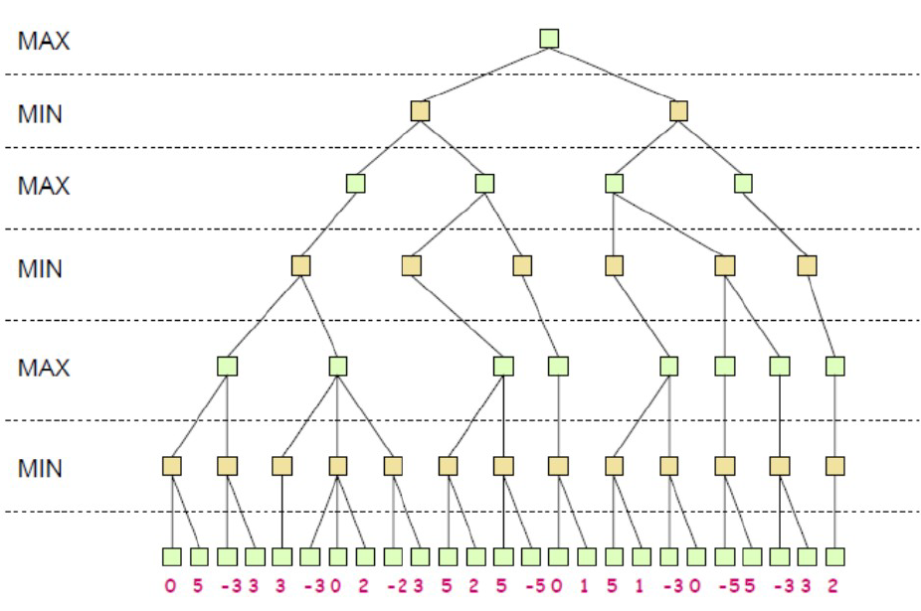
----------------------------------------------------------------------------------------------------------------
Given the following search tree, apply the alpha-beta pruning algorithm to it and show the search tree that would be built by this algorithm. Make sure that you show where the alpha and beta cuts are applied and which parts of the search tree are pruned as a result.
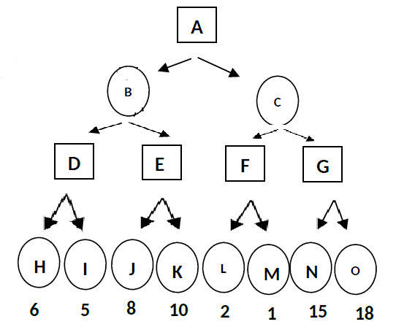
----------------------------------------------------------------------------------------------------------------
There are 5 people in John’s family. All are having different issues with one another. Due to this, before being pictured in any photograph, they must have the following constraints to be satisfied:
1. John’s father will not stand immediate position with John.
2. John’s mother will not stand with her daughter
3. John must stand between two ladies
4. John’s brother in law should not stand next to John’s father
Drive a methodology by which they can have a group photograph.
----------------------------------------------------------------------------------------------------------------
How AI handles reasoning under uncertainity? Explain with example.
----------------------------------------------------------------------------------------------------------------
Define conditional probability and explain Bayes rule in detail.
----------------------------------------------------------------------------------------------------------------
Differentiate between Data, Belief and Hypothesis & Knowledge.
----------------------------------------------------------------------------------------------------------------
A die is thrown twice and the sum of the numbers appearing is observed to be 6. Find the conditional probability that the number 4 has appeared at least once?
Answer:
A= sum of the numbers appearing on two dice is 6
=(1,5),(5,1),(2,4),(4,2),(3,3)

n(A)=5

B= number 4 has appeared at least once
=(1,4),(4,1),(2,4),(4,2),(3,4),(4,3),(4,4),(4,5),(5,4),(4,6),(6,4)

A∩B=(2,4),(4,2)
n(A∩B)=2

Required probability = P(B/A) = n(A∩B)/n(A) = 2/5
----------------------------------------------------------------------------------------------------------------
State and prove the Bayes’ Theorem. Given that probability of the statement, ‘John has a
viral’ is 0.20, the probability of John being observed sneezing when he had viral is 0.8, and
the probability of John being observed sneezing when he did not have viral is 0.2. Find the
probability of John having viral if he is seen sneezing.
----------------------------------------------------------------------------------------------------------------
a) A patient takes a lab test and the result comes back positive. It is known that the test returns a correct positive result in only 98% of the cases and a correct negative result in only 97% of the cases. Furthermore, only 0.008 of the entire population has this disease.
1. What is the probability that this patient has cancer?
2. What is the probability that he does not have cancer?
3. What is the diagnosis?
----------------------------------------------------------------------------------------------------------------
a. Illustrate Bayes Theorem and maximum posterior hypothesis
b. The following dataset gives information about stolen vehicles. Using Naïve Bayes classifier classify the new data (Red,SUV,Domestic)
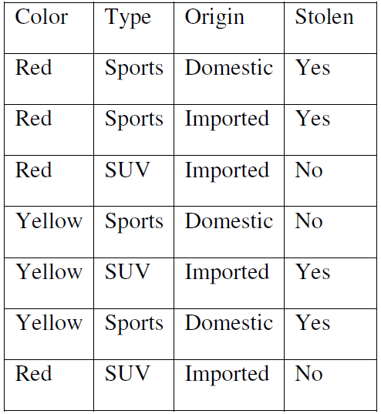
c. Outline Brute force MAP Learning Algorithm
----------------------------------------------------------------------------------------------------------------
b) Consider the training data in the following table where Play is a class attribute. In the table, the Humidity attribute has values “L” (for low) or “H” (for high), Sunny has values “Y” (for yes) or “N” (for no), Wind has values “S” (for strong) or “W” (for weak), and Play has values “Yes” or “No”.
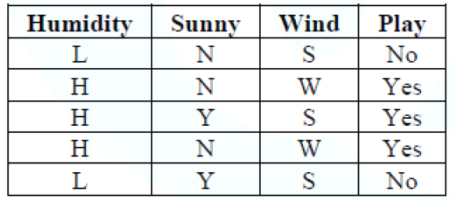
What is class label for the following day (Humidity=L, Sunny=N, Wind=W), according to naïve Bayesian classification?
----------------------------------------------------------------------------------------------------------------
Discuss Bays’ Theorem. Write down the steps of Bayesian Classification Algorithm.
Based on above data try to predict the label of given instance using Bayesian
Classification Algorithm:
Outlook=Rain, Temperature= hot, Humidity=High, Windy= false, Class=?
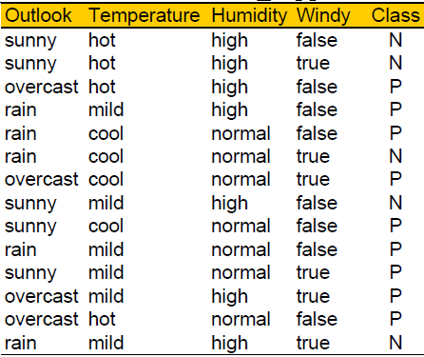
----------------------------------------------------------------------------------------------------------------
a) The following data set contains factors that determine whether tennis is played or not. Using Naive Bayes classifier, find the play prediction for the day <Sunny, Cool, High, Strong>
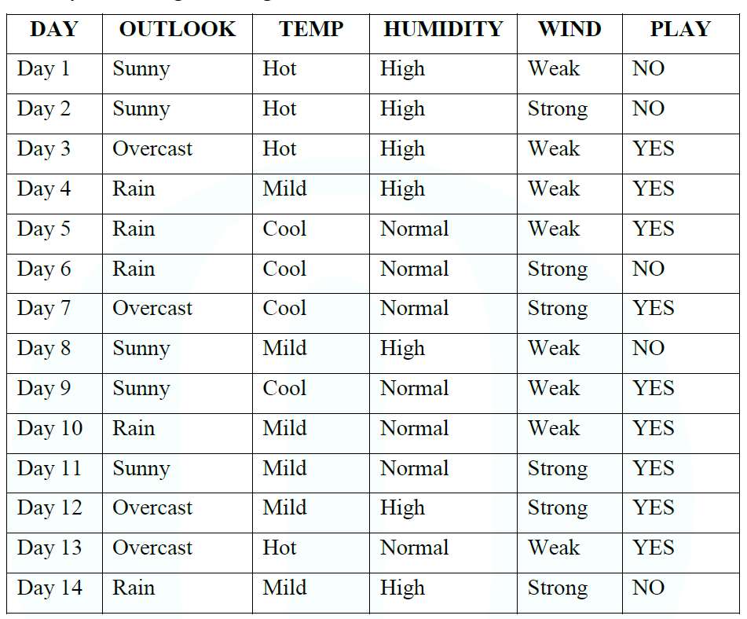
----------------------------------------------------------------------------------------------------------------
a. Bring out the steps of Gibbs Algorithm
b. Discuss the Minimum Description Length algorithm
----------------------------------------------------------------------------------------------------------------
Explain the general MLE method for estimating the parameters of a probability distribution.
----------------------------------------------------------------------------------------------------------------
Why is Bayesian rule such an important element in AI, detail with example? Define law of total probability.
----------------------------------------------------------------------------------------------------------------
a. Recall Concept Learning and also Explain hypothesis space of Find-S
b. List out the steps of Candidate Elimination Algorithm. Apply the algorithm to obtain the final version space for the training example
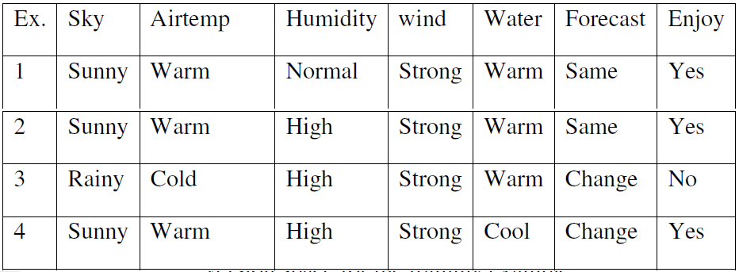
c. Compare the key differences between Find-S and Candidate Elimination Algorithm.
----------------------------------------------------------------------------------------------------------------
a) Write a short note on Bayesian networks?
----------------------------------------------------------------------------------------------------------------
In what respects Bayesian Networks are effective against dynamic relations using random variables
----------------------------------------------------------------------------------------------------------------
Consider the following Bayesian network, where X = having the flu and Y= coughing:
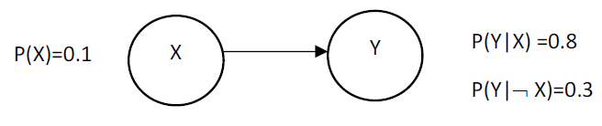
(a) Write down the joint probability table specified by the Bayesian network.
(b) Determine the probabilities for the following Bayesian network.
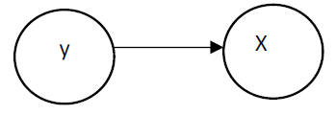
(c) Which Bayesian network would you have specified using the rules learned in class?
(d) Are Y and X independent in the given Bayesian network?
----------------------------------------------------------------------------------------------------------------
Explain the steps involved in expectation maximization algorithm.
==================================================================
UNIT – 3
6) What is learning by induction?
----------------------------------------------------------------------------------------------------------------
Explain the following in brief:
Supervised Learning | Unsupervised Learning
Supervised Learning can be used for 2 different types of problems i.e. regression and classification | Unsupervised Learning can be used for 2 different types of problems i.e. clustering and association.
Input Data is provided to the model along with the output in the Supervised Learning. | Only input data is provided in Unsupervised Learning.
Output is predicted by the Supervised Learning. | Hidden patterns in the data can be found using the unsupervised learning model.
Labeled data is used to train supervised learning algorithms. | Unlabeled data is used to train unsupervised learning algorithms.
Accurate results are produced using a supervised learning model. | The accuracy of results produced are less in unsupervised learning models.
Training the model to predict output when a new data is provided is the objective of Supervised Learning. | Finding useful insights, hidden patterns from the unknown dataset is the objective of the unsupervised learning.
Supervised Learning includes various algorithms such as Bayesian Logic, Decision Tree, Logistic Regression, Linear Regression, Multi-class Classification, Support Vector Machine etc. | Unsupervised Learning includes various algorithms like KNN, Apriori Algorithm, and Clustering.
To assess whether right output is being predicted, direct feedback is accepted by the Supervised Learning Model. | No feedback will be taken by the unsupervised learning model.
In Supervised Learning, for right prediction of output, the model has to be trained for each data, hence Supervised Learning does not have close resemblance to Artificial Intelligence. | Unsupervised Learning has more resemblance to Artificial Intelligence, as it keeps learning new things with more experience.
Number of classes are known in Supervised Learning. | Number of classes are not known in Unsupervised Learning
In scenarios where one is aware of output and input data, supervised learning can be used. | In the scenarios where one is not aware of output data, but is only aware of the input data then Unsupervised Learning could be used.
Computational Complexity is very complex in Supervised Learning compared to Unsupervised Learning | There is less computational complexity in Unsupervised Learning when compared to Supervised Learning.
Supervised Learning will use off-line analysis | Unsupervised Learning uses Real time analysis of data.
Some of the applications of Supervised Learning are Spam detection, handwriting detection, pattern recognition, speech recognition etc. | Some of the applications of Unsupervised Learning are detecting fraudulent transactions, data preprocessing etc.
6. Role of reinforcement learning in AI.
----------------------------------------------------------------------------------------------------------------
f. Role of rule based learning in AI.
----------------------------------------------------------------------------------------------------------------
Describe any four learning techniques with suitable examples.
----------------------------------------------------------------------------------------------------------------
Write the four major steps involved in the machine learning process.
----------------------------------------------------------------------------------------------------------------
b) What is machine learning? Explain about inductive and deductive learning.
----------------------------------------------------------------------------------------------------------------
List out any four applications of machine learning.
----------------------------------------------------------------------------------------------------------------
a) Distinguish between supervised learning and Reinforcement learning. Illustrate with an example.
b) Discuss any four examples of machine learning applications.
----------------------------------------------------------------------------------------------------------------
Define Machine Learning. Write down five application of it.
----------------------------------------------------------------------------------------------------------------
List down four application of Linear Regression Model with their dependent and independent variable.
----------------------------------------------------------------------------------------------------------------
Discuss and derive the mathematical proof of linear regression model.
----------------------------------------------------------------------------------------------------------------
What do you mean by reinforcement learning, explain practical applications of RL?
----------------------------------------------------------------------------------------------------------------
What do you understand by supervised and unsupervised learning? What are the characteristics and differences between them?

----------------------------------------------------------------------------------------------------------------
What do you understand by unsupervised learning? What are the major characteristics?
----------------------------------------------------------------------------------------------------------------
a) Discuss supervised learning algorithms in detail.
b) What is the difference between neural network based learning and support vector machine.
----------------------------------------------------------------------------------------------------------------
a) What is machine learning? Differentiate between supervised learning and unsupervised learning.
b) Describe case based reasoning and learning.
----------------------------------------------------------------------------------------------------------------
a) Suppose 10000 patients get tested for flu; out of them, 9000 are actually healthy and 1000 are actually sick. For the sick people, a test was positive for 620 and negative for 380. For the healthy people, the same test was positive for 180 and negative for 8820. Construct a confusion matrix for the data and compute the precision and recall for the data.
a) Explain regression with an example.
b) Differentiate between supervised and unsupervised training. Explain with suitable examples.
----------------------------------------------------------------------------------------------------------------
Explain feature selection and feature extraction method for dimensionality reduction.
----------------------------------------------------------------------------------------------------------------
Define VC dimension. How VC dimension is related with no of training examples used for learning.
----------------------------------------------------------------------------------------------------------------
a) Define Probably Approximately Learning.
b) Explain the procedure for the computation of the principal components of the data.
----------------------------------------------------------------------------------------------------------------
a) Compare Feature Extraction and Feature Selection techniques. Explain how dimensionality can be reduced using subset selection procedure.
b) Explain the methods used to learn multiple classes for a K class Classification Problem.
----------------------------------------------------------------------------------------------------------------
a) Discuss Support vector machine in detail.
b) Why is the use of Nearest Neighbor classifiers problematic in high dimensional input spaces.
----------------------------------------------------------------------------------------------------------------
Compare Classification with regression with an example.
----------------------------------------------------------------------------------------------------------------
Distinguish between overfitting and underfitting. How it can affect model generalization?
----------------------------------------------------------------------------------------------------------------
Compare supervised and unsupervised learning from overfitting & underfitting aspects and what is the possible solution to avoid them?
----------------------------------------------------------------------------------------------------------------
a) Define the terms Hypothesis space and Version space. Illustrate with an example.
b) Explain the concept of Probably Approximately Correct learning.
----------------------------------------------------------------------------------------------------------------
The sales of a company (in million dollars) for each year are shown in the table below.
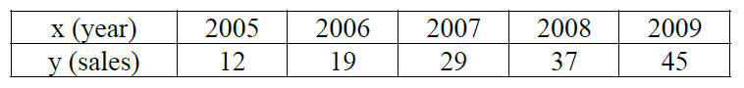
i. Find the least square regression line y = a x + b.
ii. Use the least squares regression line as a model to estimate the sales of the company in 2012.
----------------------------------------------------------------------------------------------------------------
Find the equation of the regression line for the number of hours 5 different students watched
television during the weekend and the scores of each student who took a mid-term test the following Monday. Use the equation to find the expected mid-term test score for a student
who watches 10 hours of TV.
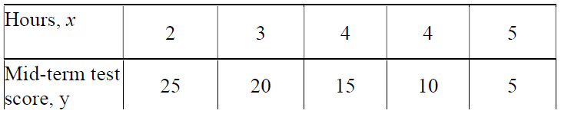
----------------------------------------------------------------------------------------------------------------
Briefly describe the concept on model selection and generalisation.
----------------------------------------------------------------------------------------------------------------
Define VC dimension. Show that an axis aligned rectangle can shatter 4 points in 2 dimension.

==================================================================
UNIT – 4

10) What is perception?
----------------------------------------------------------------------------------------------------------------
b) Explain perceptron learning algorithm.
----------------------------------------------------------------------------------------------------------------
Differentiate Biological Neurons and Artificial Neural Networks.
----------------------------------------------------------------------------------------------------------------
b) What is a Perceptron? Explain the working of a perceptron with a neat diagram.
----------------------------------------------------------------------------------------------------------------
Discuss various learning methods in neural networks with suitable examples.
----------------------------------------------------------------------------------------------------------------
Explain back propagation algorithm for nueral nets.
----------------------------------------------------------------------------------------------------------------
Draw and explain biological and artificial neural network. What are the roles of activation function in ANN? List some of the linear and nonlinear activation functions with their suitable representations.
----------------------------------------------------------------------------------------------------------------
a) What is artificial neural network? Differentiate between single layer feed forward neural network and multi layer feed forward neural network.
b) Explain back propagation algorithm with example.
----------------------------------------------------------------------------------------------------------------
a) Describe the mathematical model of perceptron with example.
b) What is learning? Explain learning in neural networks.
----------------------------------------------------------------------------------------------------------------
a) Discuss design issues of artificial neural networks.
b) Explain the architecture of artificial neural network with suitable example.
----------------------------------------------------------------------------------------------------------------
(a) Draw an architectural diagram of the McCulloch-Pitts neuron model. Write characteristics of McCulloch-Pitts artificial neural network.
(b) The input to a single-input neuron is 2.0, its weight is 2.3, and its bias is -3. It has a
linear transfer function.
i. What is the net input to the transfer function?
ii. What is the neuron output?
----------------------------------------------------------------------------------------------------------------
Differentiate between the various learning methods: neural networks, reinforcement learning and genetic algorithms
----------------------------------------------------------------------------------------------------------------
Calculate the output y of a three input neuron with bias. The input feature vector is (x1, x2, x3) = (0.8,0.6,0.4) and weight values are [w1,w2,w3, b] =[0.2, 0.1, -0.3, 0.35]. Use binary Sigmoid function as activation function.
----------------------------------------------------------------------------------------------------------------
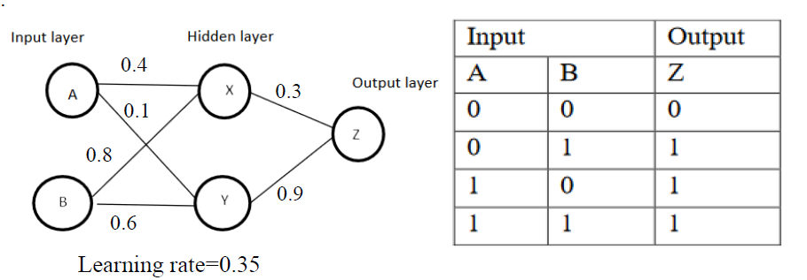
Biases are ᴓx = ᴓy = ᴓz = 0. Neural Network of above diagram has two nodes (A,B) in the input layer, two nodes in the hidden layer (X,Y)and one node in the output layer (Z). The values given to weights are taken randomly and will be changed during back propagation iterations. Initial weights of the top input nodes taken at random are 0.4, 0.1 . Weights of bottom input node are 0.8 and 0.6. Weights of top hidden node is 0.3 and that of bottom hidden node is 0.9. Assume the number of iterations are two.
----------------------------------------------------------------------------------------------------------------
Neural network is an effective tool for classification problem cases. Demonstrate how it is with the help of a sample case using network architecture, activation function and outcome.
----------------------------------------------------------------------------------------------------------------
With suitable equations, explain any two types of activation functions used in neural networks.
---------------------------------------------------------------------------------------------------------------
a. For the transactions shown in the table compute the following:
(i) Entropy of the collection of transaction records of the table with respect to classification.
(ii)What is the information gain of A1 and A2 relative to the transactions of the table?
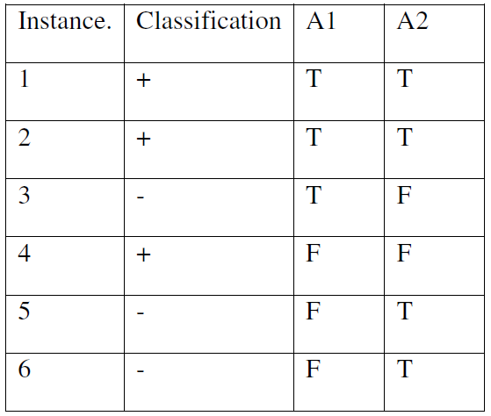
b. Discuss the application of Neural Network which is used for learning to steer an autonomous vehicle.
c. Write an algorithm for Back Propagation algorithm which uses stochastic gradient descent
method.
----------------------------------------------------------------------------------------------------------------
Explain the back propagation algorithm for neural nets.
----------------------------------------------------------------------------------------------------------------
a) Explain Multi layer perceptron( MLP ) with back propagation with schematic block diagram.
b) Design perceptrons for AND and NOT boolean functions.
==================================================================
UNIT – 5

3) What is decision tree?
----------------------------------------------------------------------------------------------------------------
Explain the process of splitting in a Decision tree. How does the tree determine which
variable to break at the root node and its child nodes?
----------------------------------------------------------------------------------------------------------------
Write a short note on the following topics
(i) Entropy
(ii) Information Gain
How does the tree determine which variable to break at the root node and its child nodes?
----------------------------------------------------------------------------------------------------------------
Explain with examples ‘Decision Trees’.
----------------------------------------------------------------------------------------------------------------
a. Outline the ID3 Decision Tree Learning method
b. Summarize the appropriate problems for Decision Tree Learning method and also bring out the issues in decision tree learning
c. Construct Decision trees to represent the following Boolean functions
(i) A and B
(ii) A or [B and C]
(iii) [A and B] or [C and D]
----------------------------------------------------------------------------------------------------------------
a) Identify the first splitting attribute for decision tree by using ID3 algorithm with the following dataset.
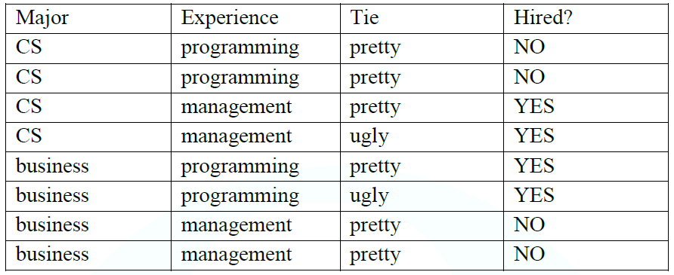
----------------------------------------------------------------------------------------------------------------
a) For the following set of training samples, find which attribute can be chosen as the root for decision tree classification
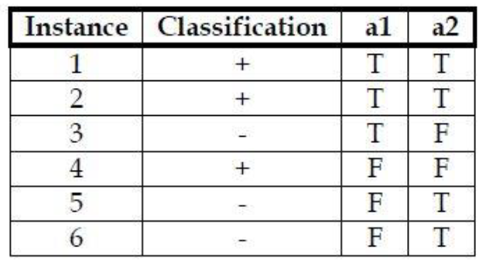
----------------------------------------------------------------------------------------------------------------
b) Discuss the issues involved in decision tree learning.
----------------------------------------------------------------------------------------------------------------

a) What are the benefits of pruning in decision tree induction? Explain different approaches to tree pruning?
b) Given the set of values X = (3, 9, 11, 5, 2)^{T} and Y = (1, 8, 11, 4, 3)^{T} . Evaluate the regression coefficients.
----------------------------------------------------------------------------------------------------------------
Data set of computer files provided, to derive model for virus identification. Considering ‘class’ as class label attribute, construct a decision tree for the given data.
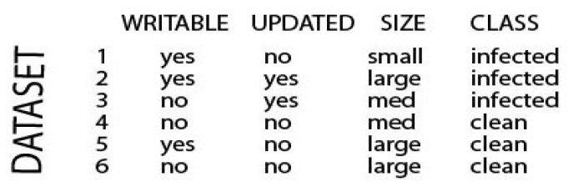
----------------------------------------------------------------------------------------------------------------
a. Discuss the learning tasks and Q learning in the context of reinforcement learning)
b. Apply K nearest neighbor classifier to predict the diabetic patient with the given features BMI, Age. If the training examples are
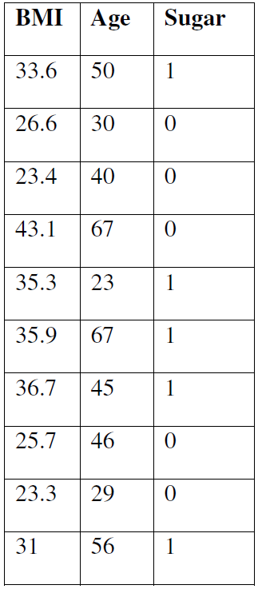
Assume K=3 Test Example BMI=43.6, Age=40, Sugar=?
----------------------------------------------------------------------------------------------------------------

