Principles of Artificial Intelligence and Machine Learning
Assignment-1

- Write a short note on model-based intelligent agent, with diagram.

- State and explain algorithm for Best First Search Algorithm with an example.

- Explain A* searching technique in detail with example. Discuss conditions for the optimality of this technique.

- Explain about hill climbing heuristic search technique.

- Discuss in detail about alpha-beta pruning.

- Discuss about Map-coloring problems, with example.

- Explain Bayes’ Theorem. Illustrate with the formula.

- It is estimated that 50% of emails are spam emails. Some software has been applied to filter these spam emails before they reach your inbox. A certain brand of software claims that it can detect 99% of spam emails, and the probability for a false positive (a non-spam email detected as spam) is 5%. If an email is detected as spam, then what is the probability that it is in fact a non-spam email?

- The following dataset gives information about stolen vehicles. Using Naïve Bayes classifier, classify the new data (Red,SUV,Domestic)

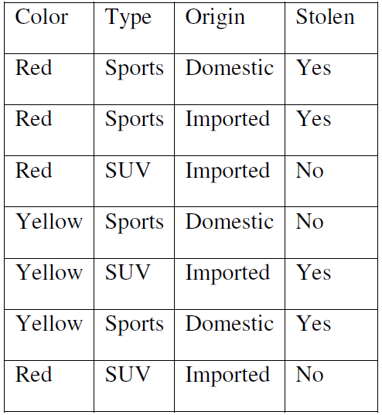

- Illustrate the difference between Supervised learning and Unsupervised learning.

